**WSN & IoT STANDARDS LAB**

**Lab 5**

**We have to create 2 project based on Operating LEDs on Motes .**

1. **First program (to blink one led at a time)**

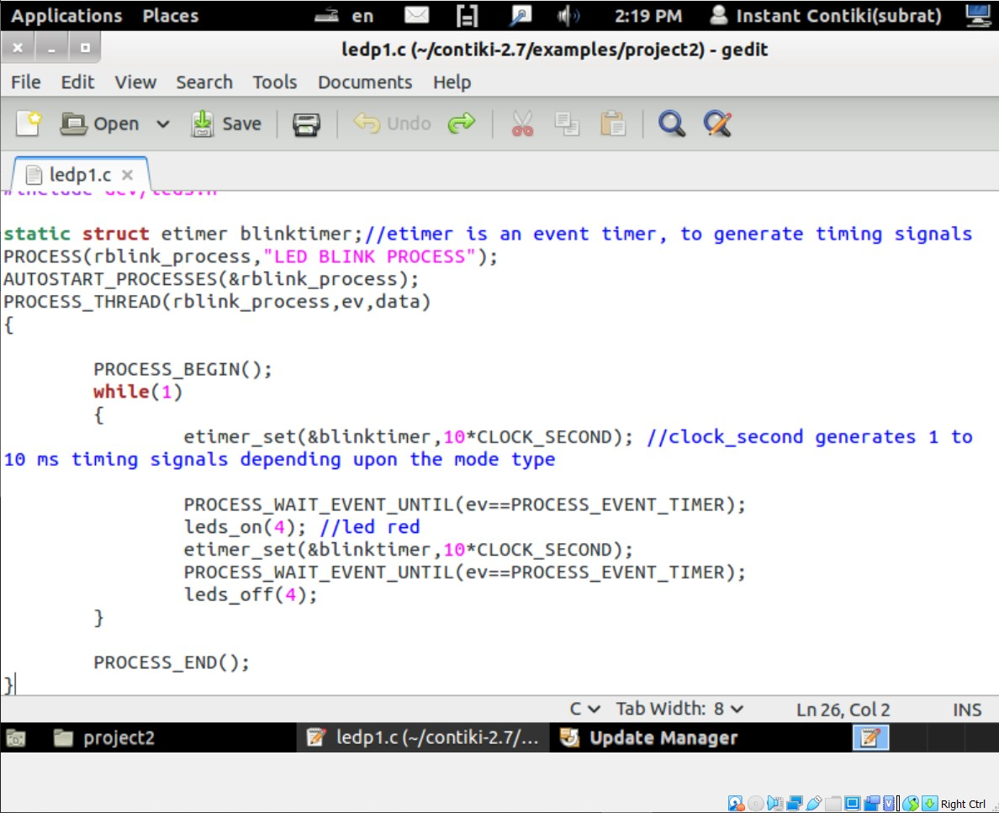

After writing this program we have to compile this program using *make* statement.

After that we have to simulate this on cooja simulator.

Below is the implementation of the above query, here we have simulated 5 sky mote. In this simulation a single led will blink at a some interval of time.

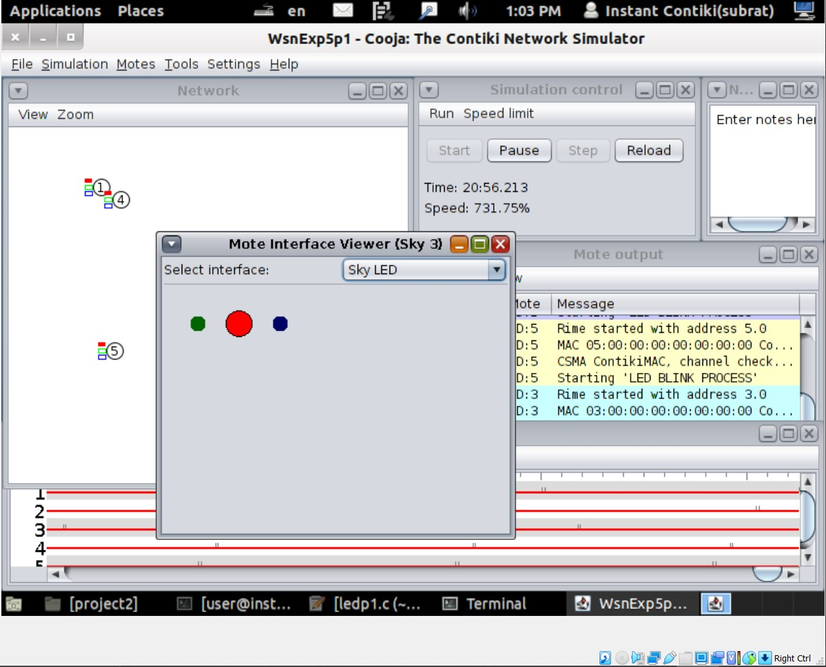

Here we have run the script and it is showing there that “Led Blink Process”.

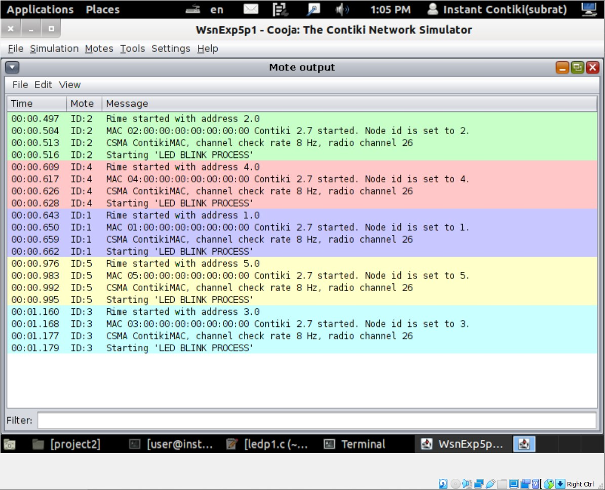

1. **Second program (to blink multiple led or a pattern of led at a time)**

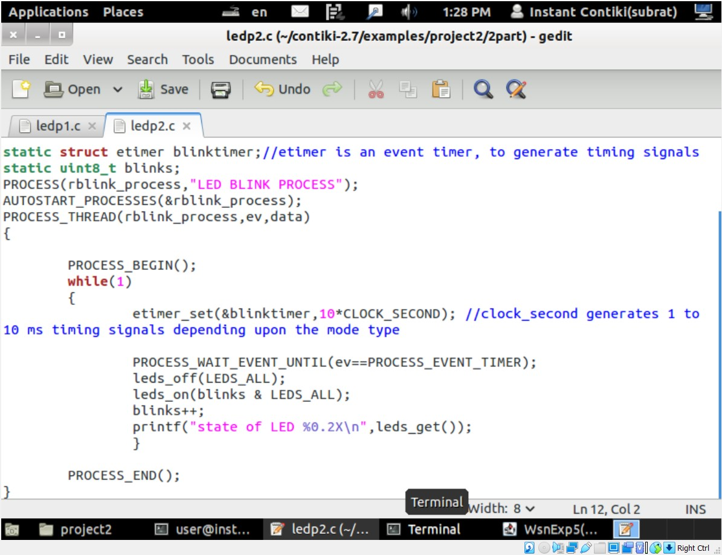

After writing this program we have to compile this program using ***make*** statement.

After that we have to simulate this on cooja simulator.

Below is the implementation of the above query, here we have simulated 5 sky mote. In this simulation a single led will blink at a some interval of time.

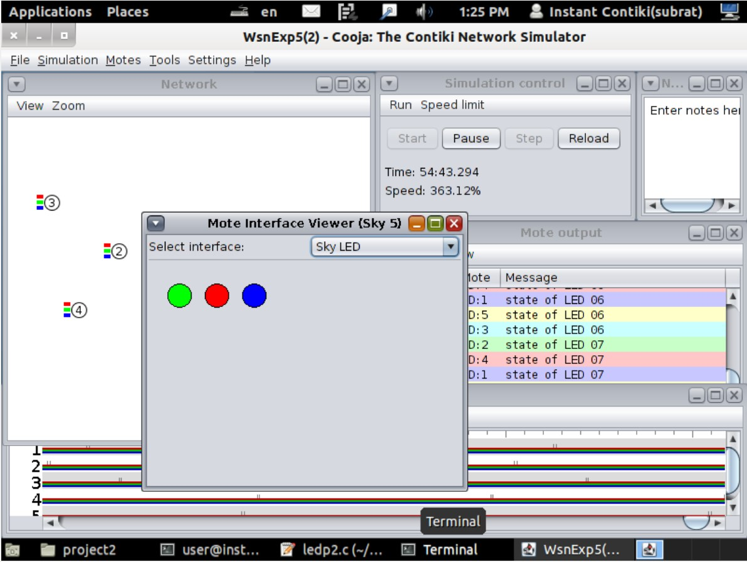

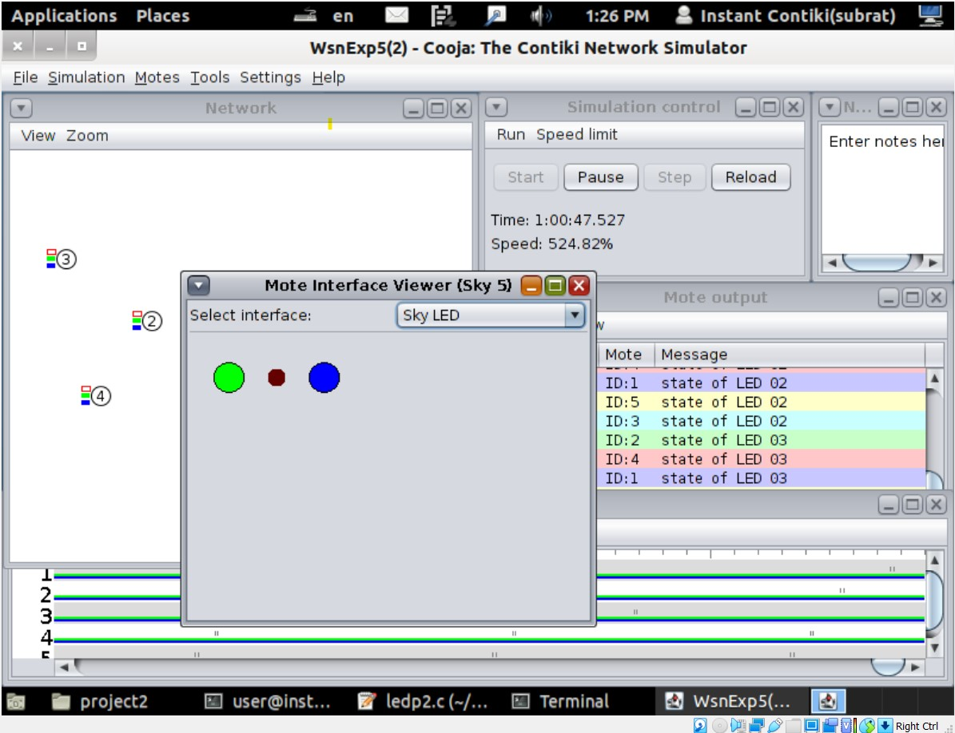

Here we have run the script and it is showing there that “Led Blink Process”.

